# Python Download and Installation

*Courtesy of Amanda Rumsey and Jessica Fayne, JCET*

## Introduction

## Python is a high-level programming language that is freely available and easily implemented across platforms. Its syntax structure emphasizes code readability and allows users to express concepts in fewer lines of code than possible in other available languages.

## Many NASA Earth Science data are available in Hierarchical Data Format (HDF). We have developed scripts in Python to read data written in HDF format and convert them into text and/or GeoTiff. This allows users to easily read and analyze the data. The scripts we provide here will also allow spatial subsetting of data from global data. In this training, we will use these scripts to read precipitation data from GPM and soil moisture data from SMAP.

## Objective

* Download, install, and test Python software on your computer

## Part 1: Download Python

* We will use Anaconda to get and maintain Python packages. Anaconda installs the Python language and 720+ open source packages that are necessary for scientific and numeric analysis.
* Go here: <http://www.continuum.io/downloads/>
* Download the latest available Python version (e.g. 3.6) for your specific Operating System (OS) – see the top bar box to select the correct operating system.
* For Linux this method is recommended for its ease of installation. An installation GUI will guide you through the installation instructions. No installation parameters in the GUI need to be changed.
* **If you downloaded Anaconda’s 3.6 version** of Python as instructed above, all packages should be installed. If you did not download the Anaconda 3.6 version, we **strongly recommend** that you upgrade to the latest version. If you have older version, this may mean reinstalling to get the current version.

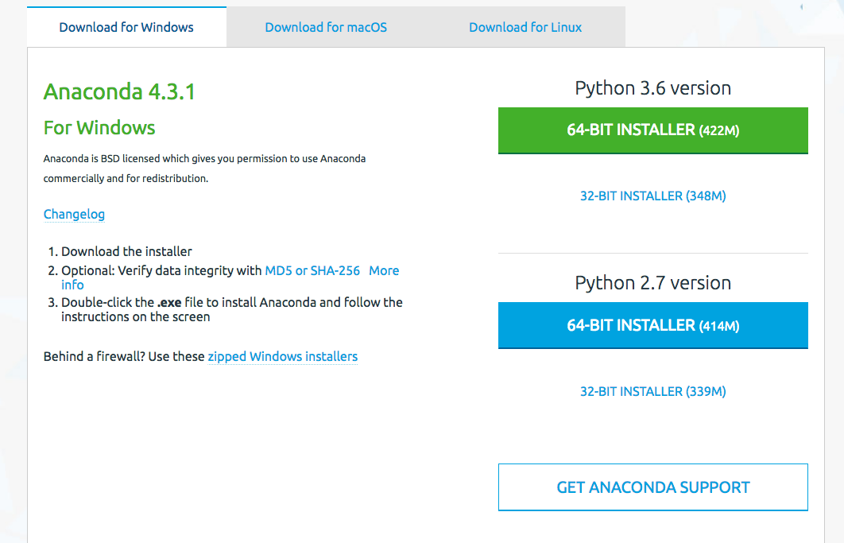

## Part 2: Check the Necessary Packages

Type ‘python’ on the command line

You will get a prompt >>>

Type ‘import gdal’

‘import os’

‘import glob’

‘import numpy as np’

‘import h5py’

‘import math’

‘import osr’

* If you run into any errors while importing packages, some of the packages may not have installed correctly on your machine.
* In the command line, install the packages you need.

The syntax is ‘conda install [package]’. [ For example : GDAL, numpy, and h5py etc.]

conda install [package name]

* You can also update packages
* conda update [package]

## Part 3: Downloading the Necessary Packages Without Using Anaconda

If you previously had python installed on your computer and want to use this version, check to see if you have the packages above by opening python through the command prompt

* Use the “cd” command to change to the directory where the python.exe file is stored, then enter “python” in the command line
* Once Python is open, type “help()” to open the help utility. From there type “modules.” This will bring up a list of all available modules.
* **Check the list to see if pip, os, glob, numpy, and h5py are available**
  + Os and glob are standard packages that come with any Python download. If you are missing pip, numpy, or h5py, refer the sections below to install the packages.

**Install and Download Pip**

* Installation instructions are available at: <https://packaging.python.org/installing/>
* If you have Python 2 >=2.7.9 or Python 3 >=3.4 installed from [python.org](https://www.python.org/), you will already have pip, but will still need to upgrade to the latest version.

**Install Download Numpy or H5py**

* Numpy, h5py, and other Python packages are available in wheel files at: <http://www.lfd.uci.edu/~gohlke/pythonlibs/>
* Python wheel files are ideal for installing python packages because they include all the necessary dependencies for a package to work. For each package available on this website, there are six available wheel files.
* There are two files for each version of python (2.7, 3.4, and 3.5). The first version is for a 32 bit operating system and the second version is for a 64 bit operating system. Select the version that matches with your version of python and operating system.
* By double clicking on the wheel you want to use, it will automatically download to your local downloads folder. At the command line, navigate to your downloads folder and type “pip install your_wheel_file” at the command line. This will download the package and all of its dependencies.